# CNN Architectures

## 1. AlexNet (2012)

AlexNet was the breakthrough model in the ImageNet competition in 2012, designed by Alex Krizhevsky. It introduced deeper networks with ReLU activation, dropout for regularization, and overlapping max pooling.

Architecture:

• 8 layers: 5 convolutional layers, followed by 3 fully connected layers.

• Uses ReLU activation instead of sigmoid/tanh.

• Overlapping max-pooling to reduce overfitting.

• Data augmentation techniques like cropping and flipping.

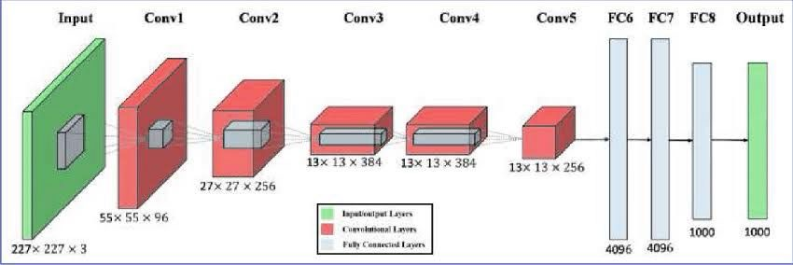

## 2. VGG (2014)

VGG, developed by the Visual Geometry Group at Oxford, is known for its simplicity and uniform 3×3 convolutional filters.

Architecture:

• Available in VGG-16 and VGG-19 variants.

• Uses only 3×3 convolutional filters stacked in multiple layers.

• Fully connected layers at the end for classification.

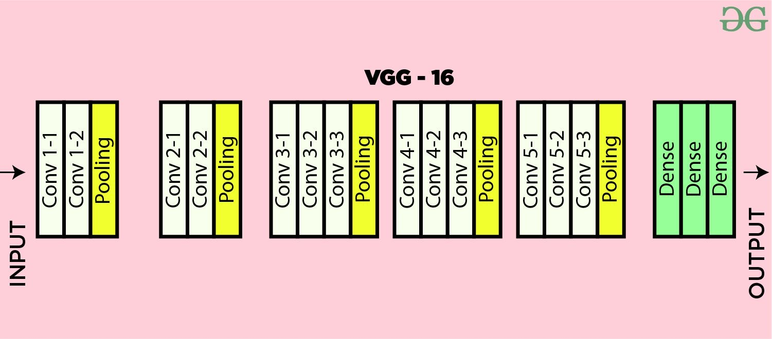

## 3. GoogLeNet (Inception v1) (2014)

GoogLeNet, developed by Google, introduced the Inception module to increase computational efficiency by using multiple filter sizes in parallel.

Architecture:

• Inception modules apply multiple convolution sizes (1×1, 3×3, 5×5) in parallel.

• 1×1 convolutions are used to reduce dimensionality before applying larger filters.

• Uses global average pooling instead of fully connected layers to reduce parameters.

